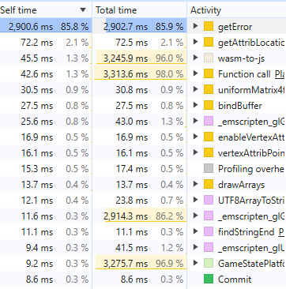

The profile is crystal clear: getError = 2,900 ms, 85.8% of all time. That's glGetError(). On native it's nearly free, but in WebGL every glGetError() is a synchronous CPU↔GPU round-trip that flushes the pipeline and stalls — it's one of the worst things you can call per frame. The engine's CHECK_GL_ERROR() macro calls it, and it's clearly running many times per frame. Let me find every call site:That's the smoking gun — glGetError is 85.8% of your frame time. The engine's CHECK_GL_ERROR() macro calls it, and there are ~18 call sites including ones in the per-draw/per-frame path (mesh draw, render-mode, frame start/end). Each call is a synchronous GL flush in WebGL, so even a few hundred per frame dominate everything. (This also explains why culling "barely helped" — fewer draws still left plenty of these sync stalls.)
The fix is one place: make CHECK_GL_ERROR a no-op on web. Let me read the macro and guard it:That's the one. CHECK_GL_ERROR() is now a no-op on web, so all ~18 glGetError() call sites disappear in the wasm build — including the ones in the per-draw and frame start/end paths. Since that was 85.8% of your frame time, this should be the big unlock: level 2 should jump from ~30 to ~60 FPS. The native Visual Studio build keeps the full error checking (where glGetError is cheap), so debugging there is unaffected.
This also explains the earlier puzzle: culling cut draw calls, but each remaining draw still triggered a glGetError pipeline stall, so the synchronous flushes — not the draws themselves — were the wall. That's why "it's not about the GL calls" was the right read: it was the GL error checks, not the draws.
Rebuild and re-test level 2:
build.bat Release
(Use plain Release, not Profile — the -g2 --profiling-funcs profiling build is itself somewhat slower and is only for inspecting traces.)
If it's now smooth, we've closed the performance work. If there's still a smaller secondary cost, re-run build.bat Profile and the new Bottom-Up top entry will point at the next thing — but with getError gone, I'd expect you're done. Let me know the result.

